How to use SpotifytoYoutube

1-select the playlist you want to transfer

2-Copy your playlist URL



3-Open https://music.youtube.com/library/playlists

4-Click new playlist

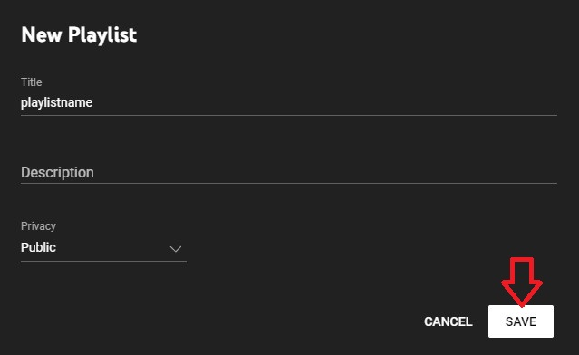

5-Open Collaborate

